HOPE OF DETROIT ACADEMY
REQUEST FOR PROPOSALS FOR
BATHROOM PROJECT

ALL INVITATIONS TO BID BY THE HOPE OF DETROIT ACADEMY WILL BIND BIDDERS TO THE CONDITIONS AND REQUIREMENTS SET FORTH IN THIS REQUEST FOR PROPOSAL, AND SUCH CONDITIONS SHALL FORM AN INTEGRAL PART OF ANY PURCHASE AGREEMENT AWARDED BY THE HOPE OF DETROIT ACADEMY.
- Definitions
  - "Hope of Detroit Academy" shall mean the Hope of Detroit Academy, a Michigan nonprofit and a Michigan public school academy chartered by Ferris State State University.
  - "Board of the Academy" shall mean the Board of Directors of the Hope of Detroit Academy.
  - “Seller” shall mean a company or group of companies providing a Sealed Bid to Hope of Detroit Academy pursuant to this Request for Proposal.
  - "Sealed Bid" shall mean a formal offer to provide goods in accordance with the policies and monetary limitations set by the Board of the Academy, the general conditions, and the specifications. The bidder to be considered must indicate proposal title and date on outside of reply.
  - "Successful Bidder" shall mean any vendor to whom an award to provide goods is given by the Hope of Detroit Academy.
  - "Specification(s)" shall mean a general description of the goods desired and the conditions for their purchase by Hope of Detroit Academy as outlined on Exhibit A to the Request for Proposals.
- General Conditions:
  - Sealed Bids - Must be received NO LATER THAN THE TIME AND DATE SPECIFIED at the location listed below. They will be opened and read aloud at the Board of the Academy’s next regularly scheduled meeting on July 27, 2021. If a proposal is transmitted by U.S. Mail, or other delivery medium, the bidder shall be responsible for its timely delivery to the designated location. Proposals must be clearly marked Bathroom Project Proposal.”
DUE DATE: July 26, 2021
TIME: 4:00 p.m. local time
PLACE: Hope of Detroit Academy
c/o Ali Abdel
4443 North Campbell St.
Detroit, MI 48210

PROPOSALS RECEIVED AFTER THE APPOINTED TIME WILL NOT BE OPENED.
  - The submission of a Sealed Bid will be construed to mean that the bidder is fully informed as to the extent and the character of the goods and a representation that the bidder can furnish the goods in complete compliance with the Specifications.
  - The Hope of Detroit Academy reserves the right to make awards within thirty (30) days after the due date of the bid opening during which time bids may not be withdrawn. Respondents shall not be allowed to modify their proposals after the opening time and date.
  - One clearly-labeled original proposal with a manual signature and two (2) copies of the proposal are to be sealed in one package clearly labeled “Bathroom Project Proposal” on the outside of the package.
  - Failure to submit one original Sealed Bid with a manual signature may result in the rejection of the proposal. All proposals shall be signed by an officer or employee having authority to bind the Seller presenting a Sealed Bid.
  - Verbal discussions of items in this Request for Proposal with the Hope of Detroit Academy or The Leona Group, LLC personnel are not to be construed as changing any of the Request for Proposal requirements. Any changes to the requirements or Specifications will be communicated in writing to the bidders by Hope of Detroit Academy.
  - The Hope of Detroit Academy reserves the right, before awarding any contract, to require the Seller to submit such evidence of qualification as it may deem necessary, and may consider any information available to it, in making the award in the best interest of the Hope of Detroit Academy.
  - The Hope of Detroit Academy reserves the right to cancel the contract or portions thereof, without penalty for reasons of funding limitations.
- Guarantees by the Successful Bidder. The Successful Bidder guarantees:
  - That the Successful Bidder has carefully checked the information contained its Sealed Bid and understands that the Successful Bidder shall be responsible for any error or omission in a Sealed Bid.
  - That the Successful Bidder has carefully examined the instructions and specifications and will provide fourth grade reading program for the price set forth in the Sealed Bid.
- Elements / Requirements of Bid.
  - Introduction. Hope of Detroit Academy seeks through this Request for Proposal to enter into a purchase agreement with a Seller to provide services to remodel the girl’s and boy’s bathrooms at the elementary campus located at 4443 North Campbell Street Detroit, Michigan 48210.
  - Background. Hope of Detroit Academy is a public school academy which has two (2) campuses located within the City of Detroit, State of Michigan.
  - Project Scope. Hope of Detroit Academy seeks to enter into a purchase agreement with a Seller that is capable of providing a high quality remodel of the girl’s and boy’s bathrooms as outlined in the Specifications.
  - Contents of Sealed Bid. The Seller shall submit a Sealed Bid for providing a remodel of the girl’s and boy’s bathrooms to Hope of Detroit Academy on or before July 26, 2021, by 4:00 p.m. in the form of one original and two (2) copies of a detailed proposal that includes information on the following topics:
    - A general description of the Seller including a brief history. Provide the name, address and telephone number of the Seller’s headquarters and the location(s) of the Seller that will be directly providing goods to Hope of Detroit Academy.
    - Describe the Seller’s availability and capability to provide bathroom remodeling services to Hope of Detroit Academy.
    - Generally, describe how the Seller would meet the Specifications by indicating any suggested modifications to the Specifications.
    - List the proposed pricing structure for the remodeling of the girl’s and boy’s bathrooms to be provided to the Academy. Please specify all billing procedures.
    - List all Michigan public school and public school academy (“Michigan Public Schools”) customers the Seller has served in the last five years. Please provide names of contact persons who are willing to share comments about the Seller’s goods with representatives from these Michigan Public Schools.
    - Has the Seller had litigation, arbitration or a claim filed against the Seller by a Michigan Public School? Has the Seller filed any such actions against a Michigan Public School? If yes to either inquiry, please provide a brief explanation.
    - A signed Iran Economic Sanctions Act Certification.
    - Signed and notarized Familial Disclosure Affidavit.
    - Please provide any other information the Seller feels will be helpful to Hope of Detroit in selecting a Seller.
- Evaluation Criteria.
  - The evaluation criteria will include, but is not limited to:
    - Quality of goods and Seller reliability.
    - Experience of the Seller and relevant personnel.
    - Capability.
    - Past performance.
    - Price.
    - Warranties, insurance and other contractual issues.
  - The Board reserves the right to accept or reject any or all Sealed Bids and to accept any Sealed Bid which appears to be the best advantage to Hope of Detroit Academy. It is anticipated that the Successful Bidder will enter into a mutually agreed upon goods / retainer agreement with Hope of Detroit Academy which shall provide for Hope of Detroit Academy’s ability to unilaterally terminate the purchase agreement upon certain conditions agreed upon by the parties.
- Submittal of Proposals. Please submit one original and two (2) copies of the Seller’s Sealed Bid signed by a duly authorized officer of the Seller. Mark outside of envelope “Bathroom Project Proposal.”
Sealed Bids should be submitted proposals to:
Hope of Detroit Academy
c/o Ali Abdel
4443 North Campbell Street
Detroit, MI 48210

Iran Economic Sanctions Act Certification

I am the __________________________________ (insert title) of ________________________ (insert company name), or I am bidding in my individual capacity (“Bidder”), with authority to submit a binding bid for the sale of windows to Hope of Detroit Academy for installation at its high school campus. I have personal knowledge of the matters described in this Certification, and I am familiar with the Iran Economic Sanctions Act, MCL 129.311, et seq. (“Act”). I am fully aware that the school district will rely on my representations in evaluating bids.
I certify that Bidder is not an Iran-linked business, as that term is defined in the Act. I understand that submission of a false certification may result in contract termination, ineligibility to bid for three (3) years, and a civil penalty of $250,000 or twice the bid amount, whichever is greater, plus related investigation and legal costs.

Signature: ________________________________ Date: __________________
Printed Name: _____________________________

FAMILIAL DISCLOSURE AFFIDAVIT
All Bids shall be accompanied by a sworn statement disclosing any familial relationship that exists between the owner(s) or any employee of the bidder and any member of the Board of the Academy, the Superintendent of the District and/or any Hope of Detroit Academy Administrator.
The undersigned, owner or authorized officer of __________________________________ (the bidder/contractor), pursuant to the familial disclosure requirement provided in the Hope of Detroit Academy Request for Proposals, hereby represent and warrant, except as provided below, that no familial relationships exist between the bidder/contractor or any employee of the bidder/contractor, and any member of the Board of the Academy, the Superintendent of the District and/or any Hope of Detroit Academy Administrator.

___ The following are the bidder’s familial relationship(s) with the Hope of Detroit Academy:
Bidder/Contractor Employee Name Related to: Relationship
1 _____________________________ ____________________ _____________________
2 _____________________________ ____________________ _____________________
(Attach additional pages if necessary to disclose all familial relationships)

___ There is no familial relationship that exists between the bidder/contractor and/or any employee of the bidder and any member of the Board of the Academy, the Superintendent of the District and/or any Hope of Detroit Academy Administrator.

Bidder:
(Company Name)

By:
(Signature)
(Title)

This instrument was acknowledged before me, a Notary Public, in and for __________________
County, _________________ on this ______ day of ________________________, 2021
______________________________________________ SS:
(Notary Public Signature)

My Commission expires: __________________________
Acting in the County of: __________________________

Exhibit A
Bathroom Project Specifications
The name of a certain brand, make or manufacturer does not restrict bids to the specific brand, make or manufacturer named. Other brands, makes or manufacturers may be offered as an alternative as long as they meet the requirements/specifications listed.
Hope of Detroit Academy is looking for bids to remodel the girl’s and boy’s bathrooms at the Elementary Campus.
The proposal should include the following for the Elementary Campus Girl’s and Boy’s Bathrooms:
- Removal of the following items
  - Existing sinks
    - Girl’s-10 sinks
    - Boy’s- 2 sinks in vestibule, 8 sinks in main restroom
  - Urinals/Toilets/Stalls
    - Girl’s- 10 toilets
    - Boy’s- 5 urinals, 5 toilets
  - Wall tile
  - Floor tile
- Adding the following items:
  - Touchless sinks
  - Soap Dispensers
  - Renovate bathrooms’ top to bottom (including wall and floor)
  - Inspect ventilation system
- Expand current janitorial closet
  - Add 1 washer
  - Add 1 dryer

Current Girl’s Bathroom
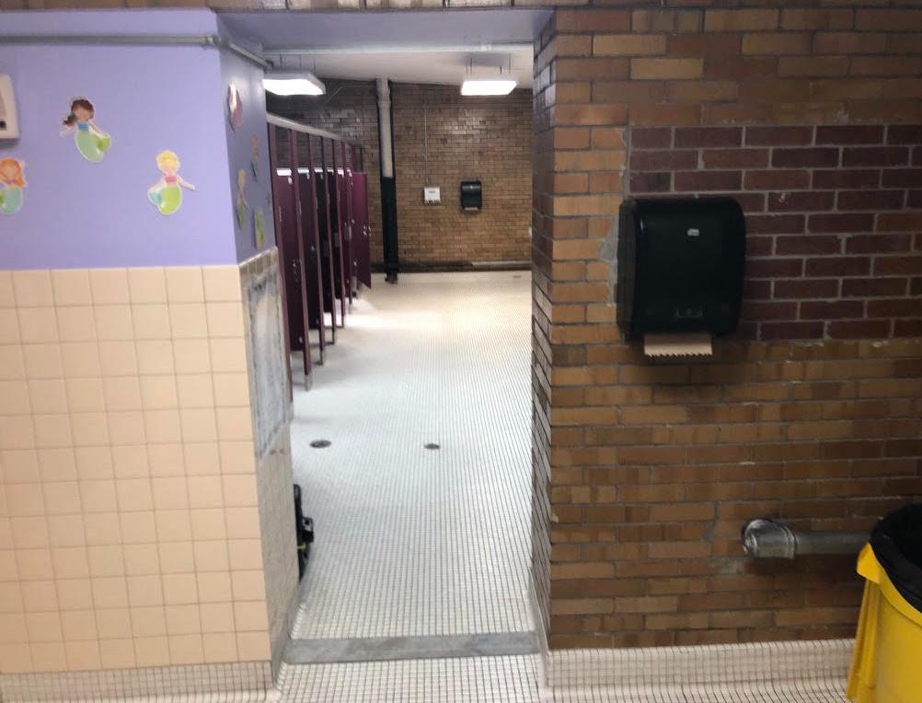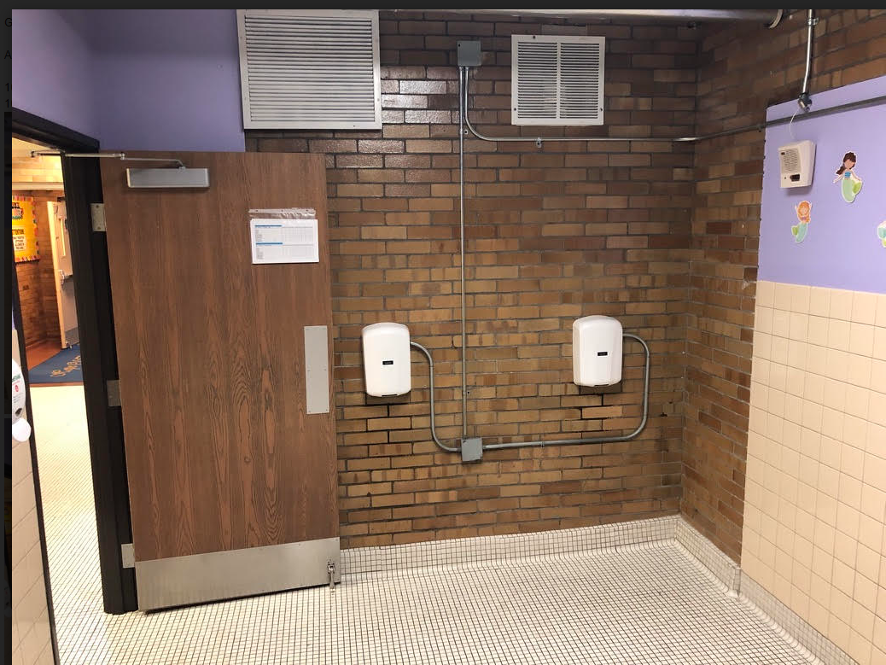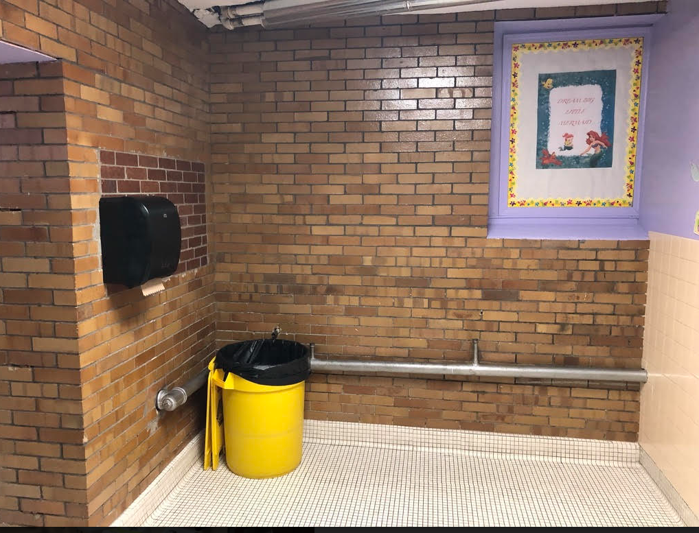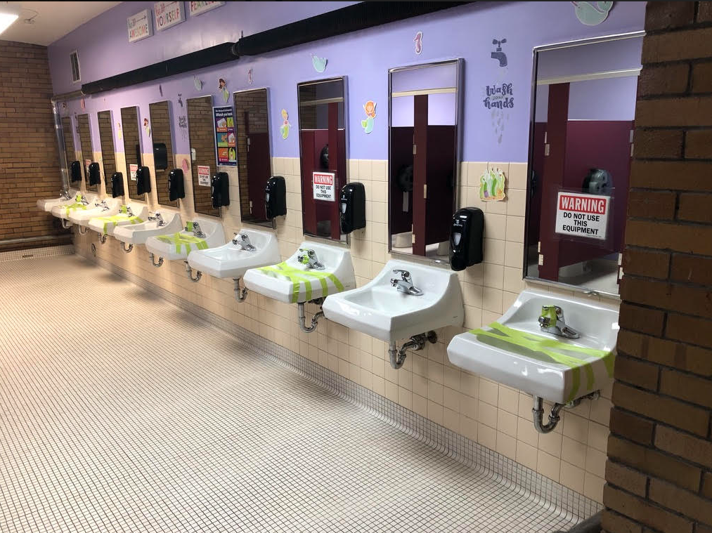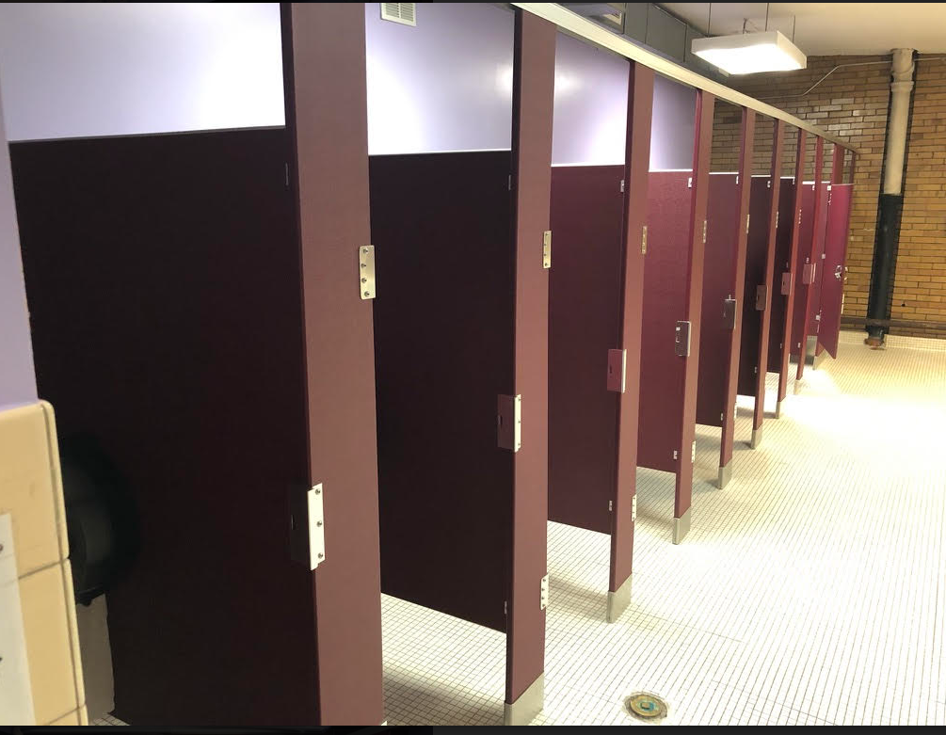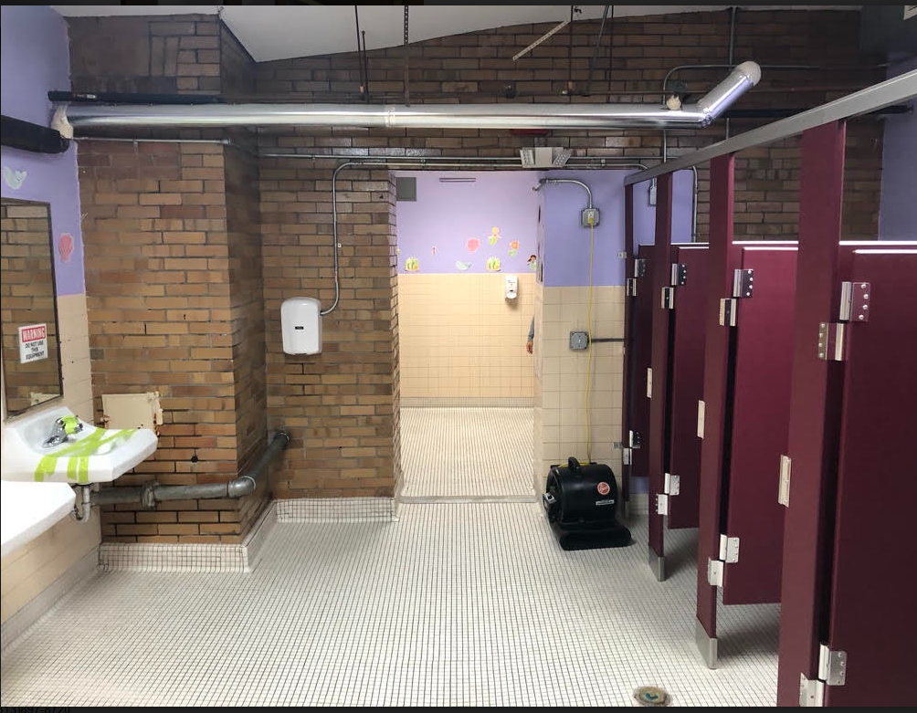

Current Boy’s Bathroom
